Pan’s Labyrinth
2006
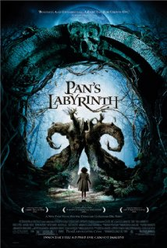
Director: Guillermo del Toro
Writer: Guillermo del Toro
Cast
Ivana Baquero (Ofelia)
Sergi Lopez (Vidal)
Maribel Verdu (Mercedes)
Doug Jones (Fauno/Pale Man)
Ariadna Gil (Carmen)
Synopsis: In 1944 fascist Spain, a girl, fascinated with fairy-tales, is sent along with her pregnant mother to live with her new stepfather, a ruthless captain of the Spanish army. During the night, she meets a fairy who takes her to an old “faun” in the center of the labyrinth. He tells her she's a princess, but must prove her royalty by surviving three gruesome tasks. If she fails, she will never prove herself to be the true princess and will never see her real father, the king, again.
Class Focus: The study of Pan’s Labyrinth will serve as a dual unit. First the class will consider the film as an example of world cinema. Since the film is Spanish, subtitles will communicate the dialogue of the film. The idea of dubbing vs. subtitles will be open for discussion. Second, the film will be studied for its metaphorical fantasy ideas used as social commentary concerning not only Franco’s brutal fascist reign in mid-20th century Spain, but a focus on violence and brutality in general. Did you like the element of fantasy as presented in the film? Why do you think that Guillermo del Toro chose to tell his story in this manner? Finally, why do you think it is important to hear the original language with subtitles in foreign films? _________________________________________________________________________________________________________________________________________________________________________________________________________________________________________________________________________________________________________________________________________________________________________________________________________________________________________________________________________________________________________________________________________________________________________________________________________________________________________________________________________________________________________________________________________________________________________________________________________________________________________________________________________________________________________________________________________________________________________________________________________________________________________________________________________________________________________________________________________________________________________________________________________________________________________________________________________________________________________________________________________________________________________________________________________________________________________________________________________________________________________________________________________________________________________________________________________________________________________________________________________________________________________________________________________________________________________________________________________________________________________________________________________________________________________________________________________________________________________________________________________________________________________________________________________________________________________________________________________________________________________________________________________________________________________________________________________________________________________________________________________________________________________________________________________________________

