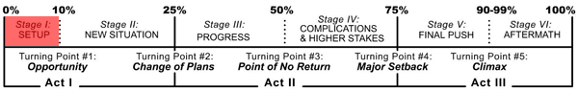
Erin Brockovich (2000)
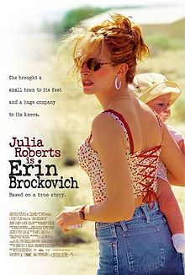
Director: Steven Soderbergh
Writer: Susannah Grant
Cast
Julia Roberts (Erin Brockovich)
Albert Finney (Ed Masry)
Aaron Eckhart (George)
Conchata Ferrel (Brenda)
Synopsis: A down and out single mother of three literally forces her way into working for the law offices of Ed Masry. Sharp, sassy, street smart and highly intuitive, Erin Brockovich stumbles upon a highly explosive situation that leads to a multi-million dollar lawsuit against a powerful corporate entity. Roberts won a highly-deserved Oscar for her career defining turn as the sharp-tongued Brockovich.
Class focus: Although the film is dominated by the development of titular character, the characters Ed Masry and George each undergo changes throughout the film. The film analysis class will examine the events and actions that complicate and change the lives and characters throughout the film.
Screenplay Structure/Character Arc Chart
Directions: Fill in the chart detailing the changing arc of the plot and conflict, as well as the changes in the characters, especially at the end. Admittedly Erin Brockovich goes through the greatest story/character arc.
Characters | Erin Brockovich (Julia Roberts) | Ed Masry (Albert Finney)
Act I

Stage 1-The setup
Stage 2-New Situation

Turning Point #1-Opportunity
TP #2-Change in Plans
Act II

Stage 3-Progress
Stage 4-Complications & Higher Stakes

TP #3-Point of no return
TP #4-Major setback
Act III

Stage 5-Final Push
Stage 6-Aftermath

TP #5-Climax

